# Signature

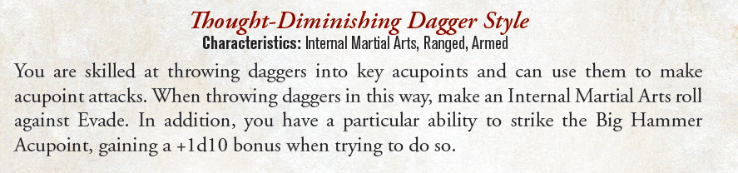

# Counter

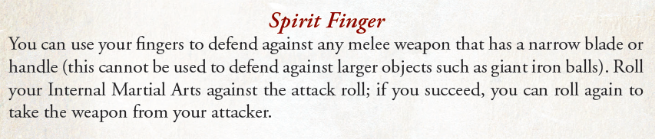

# Resources

Rare Weapon. *I stole these.*

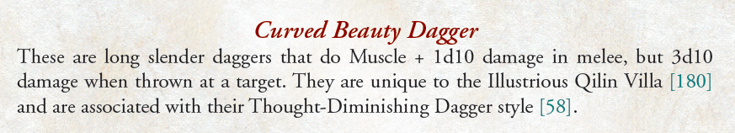

# Eccentricity

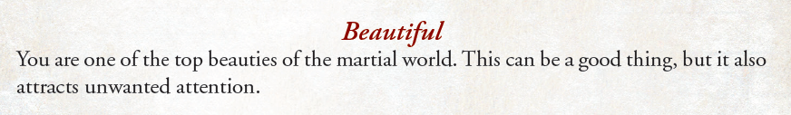

# Occupation

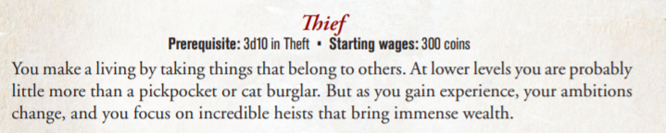

# Defences

**Evade** 8

**Hardiness** 5

**Wits** 7

# Martial Arts

**External** 0

**Internal** 3

**Lightness** 1

# Specialist

**Medicine** **and** **Alchemy** 0

**Mediation** 3

**Survival** 3

**Talent** 0

**Trade** 0

# Unorthodox

**Drinking** 1

**Gambling** 2

**Magical** **Arts** 0

**Theft** 3

# Mental

**Command** 0

**Detect** 3

**Empathy** 1

**Persuade** 1

**Reasoning** 1

Physical *Gutting beneficiary*

**Athletics** 3

**Endurance** 3

**Muscle** 0

**Ride** 0

**Speed** 3

# Knowledge *Gutted*

**Institutions 0**

**Jianghu 0**

**Peoples and Places 0**

**Religion 0**

**Scholarly Arts 0**